**Divisible by 5**

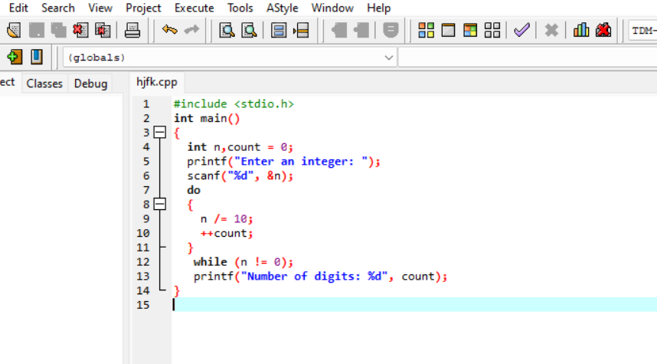

**Output**

